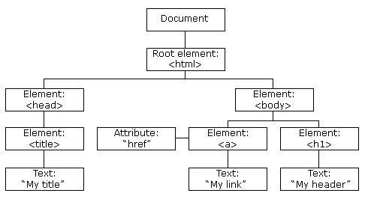

<!document>
<html>
<head>
<title>My title</title>
</head>
<body>
<a href=”Google.com”>My link</a>
<h1 id=”myhead”>my header</h1>

</body>
</html>

Finding HTML Elements
Method | Description
document.getElementById(id) | Find an element by element id
document.getElementsByTagName(name) | Find elements by tag name
document.getElementsByClassName(name) | Find elements by class name

Changing HTML Elements
Property | Description
element.innerHTML = new html content | Change the inner HTML of an element
element.attribute = new value | Change the attribute value of an HTML element
element.style.property = new style | Change the style of an HTML element
Method | Description
element.setAttribute(attribute, value) | Change the attribute value of an HTML element
Adding and Deleting Elements
Method | Description
document.createElement(element) | Create an HTML element
document.removeChild(element) | Remove an HTML element
document.appendChild(element) | Add an HTML element
document.replaceChild(new, old) | Replace an HTML element
document.write(text) | Write into the HTML output stream
Finding HTML Elements
Often, with JavaScript, you want to manipulate HTML elements.
To do so, you have to find the elements first. There are several ways to do this:
- Finding HTML elements by id
- Finding HTML elements by tag name
- Finding HTML elements by class name
- Finding HTML elements by CSS selectors
- Finding HTML elements by HTML object collections

